**SUBSIDIARIES’ PROFILE WITH LOGOS**

**REVOLUTIONPLUS CONSTRUCTION & INFRASTRUCTURE**

RevolutionPlus Construction & Infrastructure is a subsidiary of the RevolutionPlus Group aim at the constructions and building of houses and Estates. The company is led by building/construction professionals and experienced engineers who see to the complete construction of your desired plan from the architectural designs down to the actual construction.

RevolutionPlus Construction & Infrastructure handles all RevolutionPlus Property and Development Company projects.

The company has seen to the successful construction of world class properties such as;

* Flourish Apartments and Terraces, Orchid Road by Chevron
* Flourish Residences, Sangotedo
* Flourish Residences, Eluju
* Royal Haven Garden, Mowe-Ofada
* Royal Haven Garden, Ikorodu
* DreamCity, Ogombo

**VISION**

* To provide affordable housing and infrastructural solutions

**SERVICES**

* Land and Building Development
* Infrastructural Constructions
* Property Advisory services

To know more about RevolutionPlus Construction & Infrastructure, kindly check on instagram @revplusconstruction



**REVOLUTIONPLUS PROPERTY**

RevolutionPlus Property is a foremost real estate company in Nigeria; charged with a vision to be the number one real estate company in Sub-Saharan Africa as well as the world. The company which started operations in 2014 has evolved to have 6 branches in Nigeria and counting with an international office in Dallas, Texas, USA.

The company is driven by its mission to bring buyer’s real estate dreams, desires and expectations to reality through its total commitment to affordable housing using multi-channeled services.

RevolutionPlus Property boasts of owning over 30 estates in Nigeria and several homes for lease in the United States of America. The services of the company include the sales of sites and serviced plots with various affordable houses for sale across Nigeria, property development and real estate advisory. Integrity, trust and timely delivery are the core values of the organization.

RevolutionPlus Property is a member of the Real Estate Developers Association of Nigeria (REDAN).

To know more about RevolutionPlus Property, kindly check on instagram @revolutionplusproperty or visit their website www.revolutionplusproperty.com



**REMARKABLE HOTELS & APARTMENTS**

Remarkable Hotels & Apartments Limited sees to the buying, renovating, developing, building and management of hotels and short let apartments in Nigeria. It offers low-cost short & long term temporary accommodation in various strategic locations on the Island, Mainland and its environs.

With several shortlets and apartments across Lekki axis in Lagos, it is set to extend its reach to the Mainland particularly in Ikeja and its surrounding.

Remarkable Hotels & Apartments provide stylish, furnished apartments and homes in great neighborhood at reasonable prices. The Apartments are either 1 or 2 bedroom fully equipped with kitchen, utilities, cookware, dishes, HDTV, free Wi-Fi, inverter, washing machine, parking space and lots more. They are available for daily or monthly reservations with option of online booking.

To know more about Remarkable Hotels and Apartments, kindly check on instagram @remarkablehotelsandapartments or visit their website www.remarkablehotelsandapartments.com

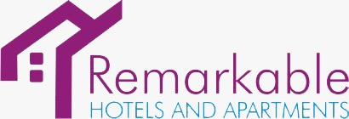

**REMARKABLE FOODS LIMITED**

With the global vision to positively impact humanity at every stage of their lives, Remarkable Foods Limited was created to cater for the everyday consumption needs of Nigerians.

Remarkable Foods boast of classy set up walk in eateries across the Island, world class standard bakery for the productions of different varieties of bread & pastries and a bottled water production line. Remarkable Foods is currently located in Lekki and Ikeja.

To know more about Remarkable Foods Limited, kindly check on instagram @remarkable.foods



**CHRIS BAMIDELE ONALAJA FOUNDATION (CBOF)**

Chris Bamidele Onalaja Foundation popularly known as CBOF was created with the vision to contribute to the sustainability, growth and development of humanity. The Foundation’s core areas are;

* Education
* Child and Maternal Health
* Education and Scholarship
* Economic and Community Development
* Widows Empowerment
* Water sanitation and hygiene
* Disease

Over the years, Chris Bamidele Onalaja Foundation has empowered several widows with financial support and skills acquisition trainings; the foundation has also provided support for childcare and youth empowerment.

Its community outreach was particularly aggressive during the 2020 COVID-19 lockdown when the foundation through RevolutionPlus Property distributed palliatives to over 1,000 households in Lagos.

In addition, the foundation built a standard private school, TolDel Nursery and Primary school in Ikorodu to provide free education to less privileged children whose parents cannot afford a private school in the axis. Educational grants and scholarships are also provided for students up to the university level.

In 2021, RevolutionPlus Group under the CBOF foundation launched an initiative to empower at least 150 widows per quarter and the foundation made a budget grossing over #10,000,000 for their startup kits. In addition to these, the foundation executed the following;

* Built a Police station at Ijebu- Ishonyi
* Drilled 2 boreholes for the community (Ijebu- Ishonyi)
* Free Health Screening (Ijebu- Ishonyi, Ikorodu, IbejuLekki, Abeokuta, Ibadan)
* Free scholarship grant to students

To read more about CBOF, kindly visit [www.cbofoundation.org](http://www.cbofoundation.org) or check on instagram @cbofoundation

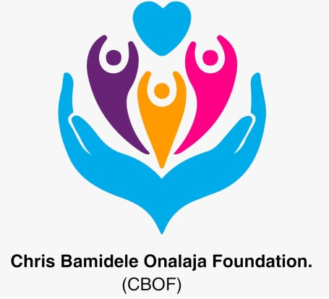

**REMARKABLE IMPACTS INVESTMENT CLUB**

Remarkable Impacts Investment Club is a real estate investment hub driven by the vision to enrich members through investments in Real Estate.

Remarkable Impact Investment Club offers 5% returns on 6 months investment; 12.5% returns on a year’s investment, 15% returns on 2 years investment, 17% returns on 3 years investment; and 20% returns on 5years investment. Investment capital starts from N 1Million and above.

Invested funds will be channeled to the development of houses and estates while profit from all investments will be shared amongst members. Members can also use invested funds to purchase some of RevolutionPlus Property’s sites and serviced plots or houses.

The club also gives up-to-date information on Real Estate Investments, grants access to portfolio funds’ investments.

To know more about Remarkable Impact Investment Club, kindly check on instagram @investinremarkable

**PUT LOGO**

**REMARKABLE IMPACT FACILTY MANAGERS**

This arm of the Group is charged with the responsibility of managing facilities for company, agencies organizations and homes. Some of the services rendered by the company include office/home equipment repairs, property maintenance, security services, janitorial services etc.

To know more about Remarkable Impact facility Managers, kindly check on instagram @ @rifmanagers

**PUT LOGO (COLLECT FROM CHIKEKA)**

**REVPLUS SCHOOL OF REAL ESTATE.**

This school was borne out of the passion to impact budding realtors and real estate consultants with the knowledge of the Real Estate industry. With the peculiarity in the real estate industry especially in Lagos, sound knowledge of products and services are required to be a successful realtor or consultant. The school is championed by seasoned professionals from the fields relating to the real estate industry.

To know more about Revplus school of real estate**,** kindly check on instagram @ @revplusschool

**PUT LOGO**

**ANGELIC LINGERIE**

Angelic Lingerie Limited is the arm of RevolutionPlus Group birthed from the desire to provide quality and affordable undergarment. The brand stands on the mandate to design comfortable, classy and stylish underwear for both male and female gender. The brand caters for all classes of consumers be it high end or just classy seekers.

Angelic Lingerie has its own registered trademark with customized designs and production line from the United State of America. The brand also sells other high end designers lingerie and labels for customers who have specific preferences.

Angelic Lingerie is situated on the Island with plans to expand outlets across Nigeria.

To know more about Angelic Lingerie, kindly check their instagram handle @angeliclingerie

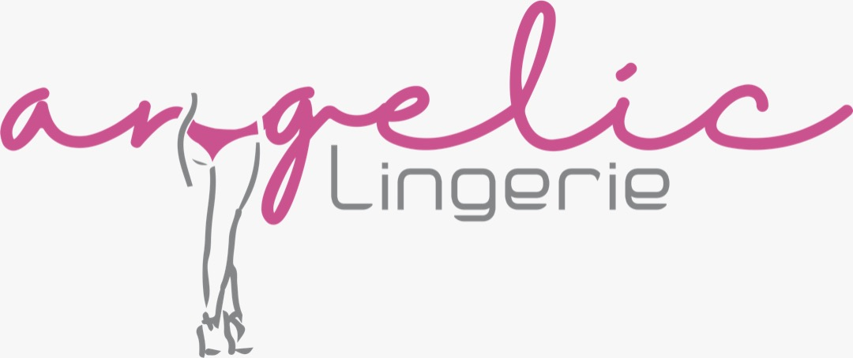

**HAPPY BET**

Nowadays, one of the easiest and fastest ways of making quick cash is through a verified betting platform. Happy Bet is not just a betting platform but a platform where every gamer wins irrespective of the amount put in. We have the best odd games, over and under, gold goal, BTS and more. Happybet is Nigerian’s number 1 plug as regards betting.

Happy Bet… bet happy, live happy.

To know more about Happy Bet, kindly check their instagram handle @happybet

**PUT LOGO (COLLECT FROM CHIKEKA)**